Analyzing Sleep Stages in Home Environment based on Ballistocardiography
Hongbo Ni¹, Tingzhi Zhao¹*，Xingshe Zhou¹，Zhu Wang¹, Lei Chen¹, Jun Yang²

1: School of Computer Science, Northwestern Polytechnic University, China
{nihb, zhouxs@nwpu.edu.cn}, transitwang@gmail.com, bmtingzhi@163.com, losemyheaven@126.com
2: Aeromedicine Institute of P.L.A, China
marrow@sina.com
Abstract Currently, a number of people have various sleep disorders, and sleep stages play an important role in assessment of sleep quality and health status. This paper proposes an effective approach of analyzing the sleep stages based on ballistocardiography (BCG), which can be continuously detected with micro-movement sensitive mattress (MSM) in this work, during non-intrusive sleep in home environment. This paper focuses on extracting features from BCG from the following three aspects: multi-resolution wavelet analysis of the heartbeat intervals based time-domain features, Welch's power spectrum estimation based frequency-domain features and the detrended fluctuation analysis (DFA) value for long term correlation based features. Moreover, the support vector machine (SVM) with or without the factor of sleep rhythm, and recurrent neural network (RNN) are adopted to build the classifiers, and both the personal model and self-independent model are investigated for different scenarios. Experimental result of 56 subjects [25 women and 31 men, aged from 16 to 71] was evaluated applying the proposed method and compared to the result provided by professional visual scoring by ECG and EEG. The SVM with the factor of sleep rhythm shows better performance with an average accuracy between 73.21%~83.94% in the personal model, and the self-independent model also achieves a satisfactory level with an average accuracy of 73.611~78.78% for male and 73.99%~ 79.46% for female.

Keywords: Heartbeat Interval, BCG, Wavelet Analysis, Sleep Stage
1 Introduction
Sleep staging is very important and effective to estimate clinical and health status of people: the sleep rhythm including time possession of each stage and its variances are related to sleep quality assessment; People in slow wave sleep，i.e. deep sleep shows harder to be wakened and will be more drowsy when awake; Sleep-related disorders serve as an significant contributor to poor health and are closely associated with sleep disease, such as Insomnia, Obstructive Sleep Apnea-hypopnea Syndrome (OSAS), Parkinson's disease, etc.[1,2,3]. Thus sleep staging has drawn a great attention to health care and medical community.
In sleep medicine, PSG has been the golden standard to divide sleep time into Not Rapid Eye Movement(NREM) and Rapid Eye Movement(REM) by visual scoring, the REM is further subdivided in stages 1,2,3,4,with a set of rules in Rechtshaffen and Kales science 1968[4]. However, PSG demands the subject to be attached with complicate and numerous electrodes during the recording of the perceived bio-signals, and it really disturbs the subject’s natural sleep. Comparatively speaking, ECG is more convenient to record cardiovascular and respiratory information, and based on the detected heart interval series, the analysis of heart rate variability(HRV) has be widely applied in sleep staging, but the electrodes are still not suitable for continuously monitoring in daily living environment[5,6]. Actigraphy is a useful tool to track the motion of a subject for longitudinal sleep monitoring with a wrist-worn accelerometer [7]; A wearable health care system based on knitted integrated sensors had been presented for the sleep data acquisition [8]; Moreover, some researchers designed sleep monitoring systems with smart phones, using the built-in sensors to monitor stage-related presentations, such as subjects acoustic event, body movement and illumination condition [9]. Unfortunately, all of them are insufficient to get physiological parameters for the fine-grained sleep staging.
The BCG is a vital signal which is caused by the movements of the heart and blood [10]. In home environment, it can be acquired unobtrusively through pressure-sensitive sensors integrated into mattress.
With BCG signal, diverse approaches offer fine properties of non-stationary time series in extracting features, some of them are Wavelets analysis, Empirical Mode Decomposition, Time-Frequency analysis and Time-Varying Autoregressive Model (TVAM) analysis [11]. The methods based on machine learning and artificial neural network have also be widely used to construct the classifiers for different sleep stage. In paper[12,13], the Time-Varying Autoregressive Models (TVAMs) serve as feature extractor from the bio-signals, and the Hidden Markov Models (HMM) is chosen to be a sequential classifier; Fast Fourier Transform(FFT) is used as a main feature extraction tool in paper[14] and a feed forward artificial neural network as a classifier; And in paper[15], the Hilbert-transform-based is adopted to derive RR-based features and the quadratic discriminant classifier (QDC) based on Bayes’ rule is also used to be the classifier.
In this paper, we present a systematic approach to assess the stage of sleep by BCG signal, which is obtained non-intrusively by the pressure-sensitive oil tubes embedded in the MSM. In section2, we briefly describe the data acquisition platform and data sets. In section3, the methodology is presented for designing classification models, as shown in Fig.1. Firstly, in order to mining features as complete as possible, we consider from the following respects: multi-resolution wavelet analysis is used for heartbeat interval based features, Welch spectrum estimation is applied to both initial BCG and the detected sequence of heartbeat intervals, DFA draws imply patterns in long term correlation analysis serving as an effective factor for sleep staging. Secondly, eliminating the redundant and irrelevant features by the principal component analysis (PCA) algorithm, we adopt SVM and RNN as the main classifiers for sleep staging. Finally, we design personal model and self-independent model adapting to different scenarios. Section 4 evaluates our approach by investigating the gap between true sleep stages and estimated results.
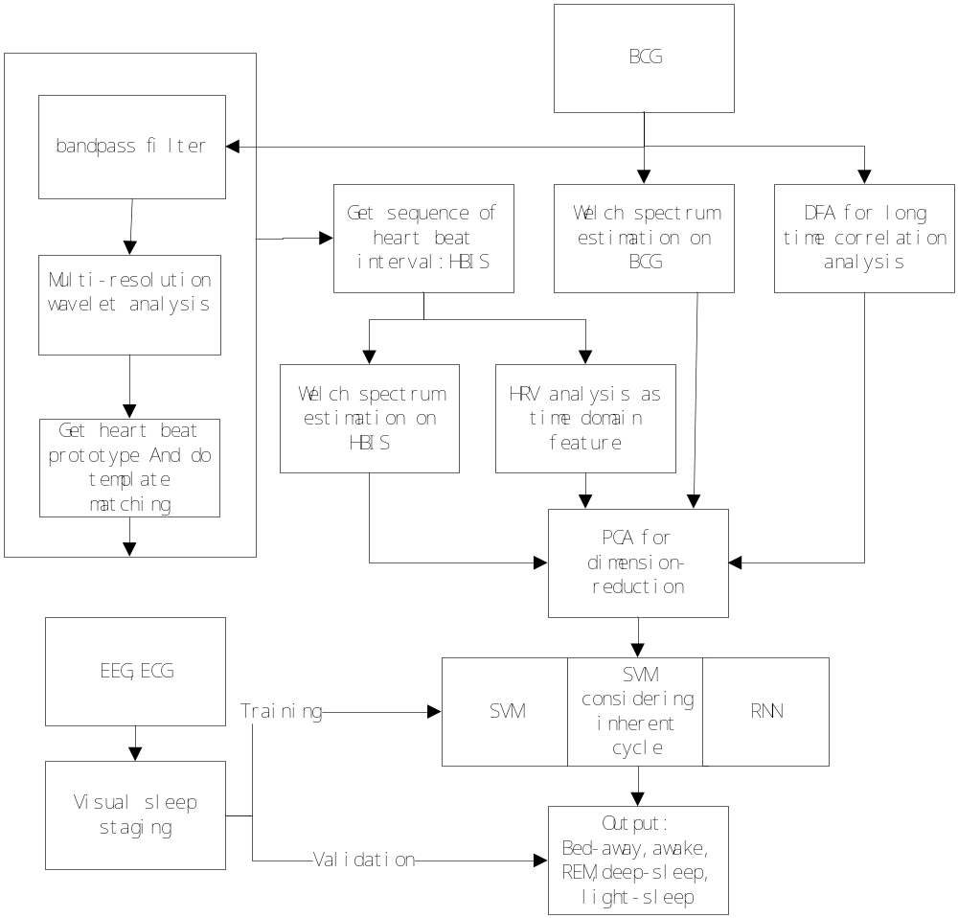

Fig.1.BCG signal processing methodology
2 Data acquisition
The non-intrusive sleep sensing system consists a micro-movement sensitive mattress, the analog-digital (AD) converter and a terminal PC. The mattress is embedded with two Hydraulic pressure sensors (oil tubes), one is located at upper part of the mattress (i.e. chest area) to sense the pressure of the heartbeat, and can make sure there is enough area for various subjects’ physical sizes; the other is placed at the leg region. The original pressure will be recorded and amplified, converting to digital signal by the AD converter, and then we apply 16 bit resolution to sample these digital signals at the rate of 100 Hz. In this work, we pay more attention to the cardiac vibrations of subjects, so we only analyze BCG signal from chest area. There are 56 subjects participated in the experiment (25 women and 31 men, aged from 16 to 71), and for each subject we have recorded the sleeping data at least three nights, and the time duration is usually from approximately 8 pm to 10 am at the following day. Since wearing too many electrodes in PSG recording would disturb people’s sleep, we only detected EEG and ECG which could record subjects’ brain activity and cardiac physiology. They have been widely used for sleep staging, and then the expert clinicians score EEG and ECG data with the outputs: bed-away, awake, REM, deep-sleep, and light-sleep.
3 Methodology
3.1 Signal pre-processing
The acquired BCG data not only includes the information of heartbeat, breath, body movement, but also includes environment noise, so it is necessary to remove the noise from the sensing data before BCG analysis. In this work, we applied Butterworth Low Pass Filter to filter the signal higher than 20 Hz, the BCG signal is retained.
As we know, many research have been done to do sleep staging from BCG signal, in this paper, we come up from the angle of heartbeat interval’s detecting, and extract time domain features from it.
3.2 Multi-resolution wavelet analysis
Multi-resolution wavelet analysis is one of the most popular candidates of the time-frequency-transformations, benefiting from its great ability in analyzing signals at multiple scales, even in the presence of non-stationarity [16, 17]. This method has been successfully used to detect heartbeat interval from bio-medical signal [18, 19]. According to the scale-dependent property, we can refine detailed information by the standard deviation of wavelet coefficients, which has been demonstrated to be better than the scale-independent measures.
In heartbeat interval detection, we just focus on identifying the approximate shape of the heartbeats, but not take care of the details. Based on the advantage of wavelet analysis, fine-grained information contains the details, and the remained is coarse-grained information which describes the prime tendency and structure of the signal. Thus, it is adopted in the processing of BCG signal. When determining the optimal layers, we prefer to choose only one particular layer rather than reconstructing on several layers. While choosing a specific layer, smaller layers existing many glitches increase our difficulty for heartbeat detection, while larger layers make the signal “more smooth”, leading some heartbeats missed or misjudged for its over distortion. Fig.2(a) shows a segment of pre-processed BCG, nearly 27 seconds, high-frequency noise mixed in our expected shapes, and from Fig.2(C), we find the signal is too smooth to distort the shape ‘W’ into ‘v’ at the third seconds.

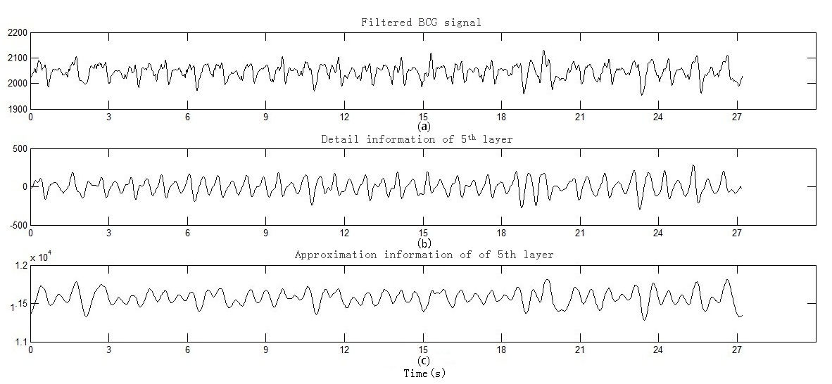

Fig.2.multi-layer wavelet analysis plot
After a series of experiments, we observed that the detail information of 5th layer (shown on Fig.2 (b)) could satisfy our requirement, which not only depicts the overall shape of heart beat, but also fairly smooth for the interval detection. After that, we calculate the extreme points and the distance among them, and then get the heart beat profile by k-means clustering algorithm on a short segment. The average value calculated by this method is then regarded as the representative template of the BCG for further processing. In detail, do template matching between the prototype segment and the remained signal for peak position finding. Then we adopted both Euclidean distance and auto correlation function in the procedure, and the corresponding maximal position and maximal position indicate highest heartbeat response [20]. Fig. 3 shows the detected sequence of heart beat intervals (HBIS) during 30 minutes.
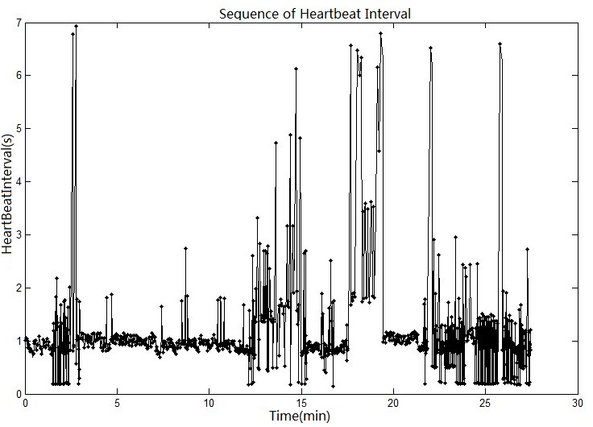

Fig.3.The intervals of the detected HBIS
From Fig.3,we can see that during 0~2min and 4~12min, the subject has a normal heartbeat with interval around 1sec; At around 3min, 23min~27min, the heartbeat interval fluctuate up and down in a narrow range, representing that the subject’s cardiac condition is a little unstable. In the period of 13~15min and 18~19min, the intervals show big fluctuation implying body movements on the bed. For a large amount of information can be gained from HBIS, it’s necessary to extract features for sleep staging.
3.3 Features based on HBIS
Time-domain analysis is obviously optimal to be adopted, because it’s usually applied in the HRV analysis and it contains plentiful information of heart, blood vessels and nervous-humoral regulation [21]. Thus, based on HBIS, the properties of HRV [22] are reliable to be treated as time-domain features for sleep stage classifications, and they are shown in Table 1.

Table1. Time domain features calculating from HBIS
Feature | Explanation
MI | The mean values of heartbeat intervals.
SDNN | The standard deviation of successive heartbeat intervals, estimating the overall variation within the total sequence.
SDANN | The standard deviation on average, reflecting the slow variation.
RMSSD | The root mean square of successive difference, reflecting the rapid variation.
RMSSD | The root mean square of successive difference, reflecting the rapid variation.

3.4 Welch spectrum estimation
The power distribution and central frequency of the spectral components vary a lot depending on the central nervous system rate, so power spectral density(PSD) of the bio-medical signal has been widely used in application of frequency representations[23,24]. Welch method is a good choice to calculate PSD due to the improved periodogram, since it shows much smoothness of the signal’s spectrum curve [25, 26]. Specifically, the original signal is separated into equivalent digitalized segments, overlap with the Hamming sliding windows, and calculate the PSD with FFT. Fig.4 depicts the PSD of both HBIS and the original BCG by Welch, and after exploring the PSD of each segment of signal have little difference with others, we choose several frequency band and calculate its integral power for every band as the features of the segment. Then for each segment, we can get the frequency features in the fixed frequency band.Table2 depicts 12 frequency features from HBIS and BCG for each segment.
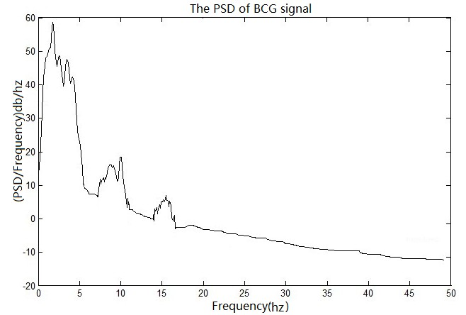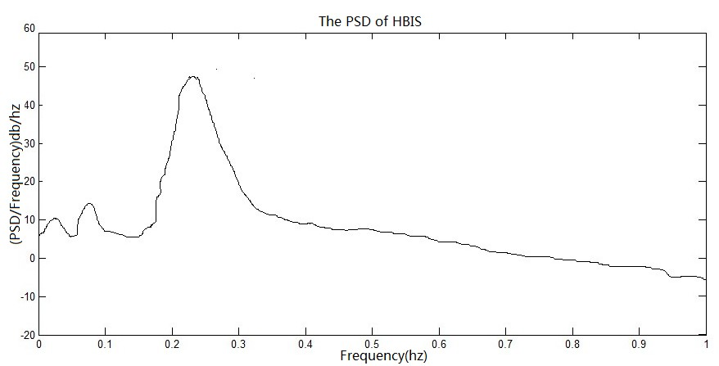

Fig.4.The PSD of BCG and HBIS
Table2. Frequency Features calculating from HBIS and BCG
HBIS | BCG
T_S: total power of segment | T_B: total power of the segment
VLF_S: power between 0.01-0.05hz band | VLF_B: power between 0-5hz band
LF_S: power between 0.05-0.15hz band | VHF_B: power between 5-11hz band
HF_S: power between 0.15-0.4hz band | VHF_B: power between11-17hz band
RLH_S: ratio between low and high | RLH_B: ratio between low and high
3.5 DFA
Besides the time and frequency domain analysis on short term, long term correlation analysis would reveal the implied patterns for each stage. DFA shows great advantages in analyzing the tendency components in the data series. It is based on the theory of random process and chaotic dynamics, and has an amendment with root mean square to the theory of random walk, so DFA is good at detecting the physical essence of time series [27]. In detail, the process flow is: segmenting a sequence firstly, removing the mean value, and calculating the summation-sequence, secondly, dividing the summation-sequence into sub-sequences with same length, finally, removing the trend of each sub-sequence and regarding the average for the square of all the sub-sequences as the DFA fluctuation value.
3.6 Feature subset selection
In each short term, we can extract 5 time-domain features and 12 frequency-domain features, and in long term, we can also get DFA value as a feature. Every long-term contains multiple short-term leading multi-group short-term features. However, with various classifiers in statistical methods, machine learning, and neural network, the addition of feature containing little or no relevant information in the classification process will not increase the performance of the classifier, but could increase the complication feature matching and consume system resources. Thus, before constructing the model, we should remove the redundant and irrelevant features by finding some effective subset combination, and these subsets make most of contributions for the classifiers or mapping the initial features into lower dimensions by linear transformation. In this paper, we adopted principal component analysis (PCA) algorithm [28] to demonstrate the discriminatory power for eigenvectors detecting, and make contribution rate cumulatively to 95%.
3.7 Classifiers

SVM: Support vector machine (SVM) is a powerful machine learning technique. Based on statistical learning theory and minimum structure risk, its purpose is to seek compromise between model complexity and autonomous learning ability-predictive accuracy [29]. SVM shows great advantages in resolving problems about small-sample set, non-linear and high dimensions by separating data with an optimized hyper plane and maximizing the margin between two classes. It appears in many sleep staging applications with various bio-medical. Besides, SVM has been expanded to resolve multi-class problem, such as building classifier for a certain class and the rest classes (one-versus-set), building classifiers for any two classes (one-versus-one) and building hierarchical support vector machines (H-Svms). In this paper, we employed the Matlab toolkit-Libsvm, which is implemented by the one-versus-one, to resolve our multi-class problem.

SVMps: The transition among Wake-NREM-REM stages gives information related to the sleep quality since this transition pattern is highly affected by sleep disorders and daily activities. However, SVM ignores the inherent temporality or the recognized patterns in the REM-NREM cycle, the features are only extracted by the current segment of data but not considering the transitions in adjacent segments. To avoid this weakness, we append the previous stage as a new feature and call the new classifier as SVMps.

RNN: Recurrent neural network (RNN) is a classifier of artificial neural network and the connections among units of RNN forming a directed cycle [30]. This property is equivalent to create an internal state of the network, which makes RNN describe dynamic temporal behavior, that is to say, RNN can use its internal memory to process arbitrary sequences of input, just like our time series with stage transition. From many kinds of RNN, Elman shows the ability of dynamic recurrent with varying ability, so in this paper, we apply Elman to train our RNN classifier, with one hidden layer, sigmoid function as the kernel, and sum of squares of errors as the evaluation function.
3.8 Personal model and the self-independent model
For the practicability and reliability of the classifiers, different scenarios should be considered:
1. If the subject has historical recordings of BCG signal and the corresponding ECG and EEG for visual scoring of stages, the data can be used for constructing a personal model. The personal model inheres the subject’s own characteristics, such as his sleep rhythm, activities pattern at daytime, and they will be totally reflected in the model, leading to a self-adaptive model, which shows excellent performance when his newly generated BCG data appended to the model.
2. The self-independent model seems more practical in real time applications, especially when the subject unwilling to wear any electrodes for ECG, EEG recording. They think the electrodes not only disturb their natural sleep but also regard them as patients, thus, it’s difficult to collect the labeled trusted stages for their personal models. To avoid the behavior interference and psychological conflict, the self-independent model is demanded to be built. On account of each person’s characteristic different with others, if we randomly choose some users that have training data to establish the stage recognition model and apply to new user, the accuracy will greatly reduce. Considering the reliability and practicability, a compromise solution is to divide the users into many groups, the training data of each group are associated same characteristics and share with similar sleep pattern. Then for each group we can build a model with the training data in this group. For a new person who doesn’t have training data, we just judge which group the new user will belong, and use that model to do stage recognition.
Diverse studies have shown sleep structure changing with age and gender, such as the major sleep of the infant is in deep stage; slow wave sleep decreases gradually when growing up, which reflects on the longer sleep in the daytime, circadian rhythms appear different about the stage-advanced for infant and the elderly, the latter show earlier both in falling sleep and waking up than they were young. Besides that, in senior community, female’s sleep structure is more stable than male, and women generally have more slow-wave sleep, which means the deepest sleep. So in this paper, we use the existing subjects’ data to build self-independent model according to age and gender for a new subject.
4 Experiment Evaluations
To evaluate the performance of our models, the data of 56 subjects has been recorded at least 3 nights for the experiment, and we randomly select 70% of the data as training data, and the remaining 30% is test data. For the personal model, we use ten folds cross validation to divide the 56 subjects into 6 groups randomly, with the first five group 10 subjects and the last group 6 subjects. For each group, the features of time-domain, frequency-domain and the DFA value are all extracted at first, although the golden standard PSG identifies stage by dividing sleep time in epochs with length of 30s, in fact，each stage usually sustain at least 5~10 minutes, so we also use several minutes as the segment for the stage identification. Then PCA is used to reduce the dimension and the new attributes can make contribution rate cumulatively to 95%. Finally, we apply SVM, SVMps, and RNN to the test data, the average accuracy of each group is worked out by different classifiers. In this paper, we repeat our experiments 3 times. The results are shown in the flowing tables.

Table 3.Accuracy of SVM in personal model
Accuracy (%) | (Training set)/ (Test set)
Accuracy (%) | 10/56 |  | 10/56 |  | 10/56 |  | 10/56 |  | 10/56 |  | 6/56
Experiment 1 |  | 64.0000 |  | 71.4912 |  | 70.1571 |  | 58.7940 |  | 71.2389 |  | 70.1087
Experiment 2 |  | 69.6682 |  | 72.7273 |  | 67.7596 |  | 70.0000 |  | 72.0430 |  | 74.2857
Experiment 3 |  | 76.1658 |  | 57.9487 |  | 75.3695 |  | 56.4767 |  | 64.9289 |  | 76.5306
Average |  | 69.9447 |  | 67.3891 |  | 71.0954 |  | 61.7569 |  | 69.4036 |  | 73.6417

Table 4.Accuracy of SVMps in personal model
Accuracy (%) | (Training set)/ (Test set)
Accuracy (%) | 10/56 |  | 10/56 |  | 10/56 |  | 10/56 |  | 10/56 |  | 6/56
Experiment 1 |  | 71.7822 |  | 74.0741 |  | 84.5771 |  | 78.7330 |  | 79.6117 |  | 76.7544
Experiment 2 |  | 73.5931 |  | 74.8744 |  | 79.6209 |  | 86.8182 |  | 72.1053 |  | 81.6038
Experiment 3 |  | 82.9016 |  | 71.5026 |  | 82.6733 |  | 79.3722 |  | 74.0884 |  | 76.3033
Average |  | 75.4887 |  | 73.2169 |  | 83.9425 |  | 78.9461 |  | 74.4373 |  | 76.6040

Table 5.Accuracy of RNN in personal model
Accuracy (%) | (Training set)/ (Test set)
Accuracy (%) | 10/56 |  | 10/56 |  | 10/56 |  | 10/56 |  | 10/56 |  | 6/56
Experiment 1 |  | 64.5455 |  | 72.2222 |  | 68.4211 |  | 64.8649 |  | 72.2222 |  | 66.6667
Experiment 2 |  | 78.7234 |  | 68.5714 |  | 79.1667 |  | 79.7436 |  | 63.1250 |  | 73.3333
Experiment 3 |  | 76.1658 |  | 57.9487 |  | 75.3695 |  | 56.4767 |  | 64.9289 |  | 76.5306
Average |  | 71.8750 |  | 67.0833 |  | 72.5000 |  | 68.2927 |  | 79.1667 |  | 80.9787
Table 3 shows the accuracy of SVM, whose features include time domain, frequency domain and the DFA value, the average of the three experiments on each group in range of [61.7569%,73.6417%]. While Table 4 shows the accuracy of SVMps, which has taken into account of the temporal transitions in different stages, the average accuracy is obviously improved to [73.2169%, 83.9425%] RNN automatically integrates transition behavior, which means RNN function should be better than others. However, compared with SVMps, each group’s average accuracy generated by RNN decreased except the 5th as presented in fig 5.
We guess the reason why SVMps performs better than RNN is its intrinsic quality to deal with binary problem. Because the signal we wish to classify can be decompose to several binary classifications, as Fig.5 shown, the input features are distinguished into bed-away and on-the-bed state, then the latter can be subdivided into awake and sleep state which made up of REM and NREM, while NREM can be further refined by deep sleep and light sleep, these properties exactly match the SVMps’s ability.
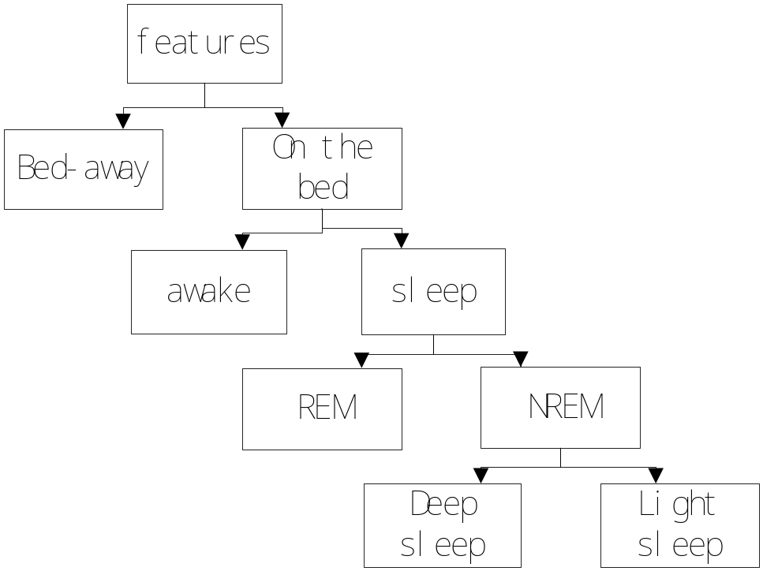

Fig.5. Stage structure
In the evaluation of self-independent model, we group the subjects by gender and age, specifically, the age is divided into 16~35, 36~55, and 56~76, as shown in Table 6. However, it’s inappropriate to use ten folds cross validation because the least number is only 5 in group of [male, 56~76] and [female, 16~35], so we use the leave on out method to train the self-independent models. Considering SVMps shows the highest accuracy in personnel model, we also use this algorithm in the self-independent model. The result (in table 6) shows that the age between 16~35 is more precise whether for male or for female, which reflects that the younger subjects may have more stable sleep stages than the older. Whatever, comparing the accuracy between male and female data set, more varieties is presumed to exist in the sleeping patterns of the female, resulting in lower accuracy than the male data set.

Table6.Accuracy of SVMps in self-independent model
Gender | Age Group(year) | Number of Subjects | Maximum Accuracy (%) | Minimum Accuracy (%) | Average Accuracy (%)
Male | 16~35 | 8 | 89.583 | 71.044 | 78.778
Male | 35~55 | 18 | 82.758 | 66.667 | 76.536
Male | 56~76 | 5 | 82.818 | 69.444 | 73.6111
Female | 16~35 | 5 | 85.416 | 72.723 | 79.455
Female | 35~55 | 14 | 83.333 | 65.278 | 75.395
Female | 56~76 | 6 | 80.227 | 63.636 | 73.989
Moreover, in this paper, we take one minute as the short term features, and for the long term duration, different segment (from 1minute to 10minutes) have be applied for the accuracy evaluation. From Fig.6, different duration shows little variations on the accuracy, the 4 minutes and 6 minutes seem more precise than others, so in the following experiment, so 5 minutes has been our appropriate choice for the duration of long term.
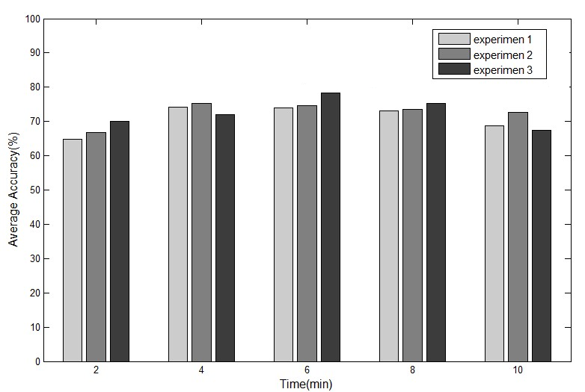

Fig.6. Accuracy for different segment

5 Conclusion
This paper proposed systematic approach for sleep staging with BCG signal, acquiring from the continuous and non-invasive sensing platform. The contribution we made in this paper can be concluded: firstly, we extracted as complete as possible features for stage classification from short term to long term, from time domain to frequency domain; Secondly, SVM, SVMps and RNN were applied to train multiple classifiers, and the SVMps showed best performance, and it relied on that, one hand, it take into account of the inherent temporality in the REM-NREM cycle, on the other hand, its intrinsic quality just matches our classification problem; Thirdly, We designed personal model and self-independent model to adapt to different scenarios. Finally, according to relatively high accuracy of the experimental result, the work is effective for sleep staging. In the future work, we will encourage more subjects to participate in this work, and improve the accuracy of sleep staging.

Acknowledgments. We thank the reviewers for the valuable comments and for the time spent towards the improvement of the paper. This work is supported by the National Found of Science of China (61332013)and Scientific Program Grant of Xi’an (CXY1340-7).

References
[1] Feige B, AL‐SHAJLAWI A, Nissen C, et al. Does REM sleep contribute to subjective wake time in primary insomnia? A comparison of polysomnographic and subjective sleep in 100 patients[J]. Journal of sleep research, 2008, 17(2): 180-190.
[2] De Chazal P, Heneghan C, Sheridan E, et al. Automated processing of the single-lead electrocardiogram for the detection of obstructive sleep apnoea[J]. Biomedical Engineering, IEEE Transactions on, 2003, 50(6): 686-696.
[3] Kim Y E, Jeon B S, Yang H J, et al. REM sleep behavior disorder: Association with motor complications and impulse control disorders in Parkinson’s disease[J]. Parkinsonism & Related Disorders, 2014.
[4] Rechtschaffen A, Kales A. A manual of standardized terminology, techniques and scoring system for sleep stages of human subjects[J]. 1968.
[5] Yιlmaz B, Asyalι M H, Arιkan E, et al. Sleep stage and obstructive apneaic epoch classification using single-lead ECG[J]. Biomedical engineering online, 2010, 9: 39.
[6] Fell J, Mann K, Röschke J, et al. Nonlinear analysis of continuous ECG during sleep I. Reconstruction[J]. Biological cybernetics, 2000, 82(6): 477-483.
[7] Ancoli-Israel S, Cole R, Alessi C, et al. The role of actigraphy in the study of sleep and circadian rhythms. American Academy of Sleep Medicine Review Paper[J]. Sleep, 2003, 26(3): 342-392.
[8] Paradiso R, Loriga G, Taccini N. A wearable health care system based on knitted integrated sensors [J]. Information Technology in Biomedicine, IEEE Transactions on, 2005, 9(3): 337-344.
[9] Gu W, Yang Z, Shangguan L, et al. Intelligent sleep stage mining service with smartphones[C]//Proceedings of the 2014 ACM International Joint Conference on Pervasive and Ubiquitous Computing. ACM, 2014: 649-660.
[10] Bruser C, Stadlthanner K, de Waele S, et al. Adaptive beat-to-beat heart rate estimation in ballistocardiograms[J]. Information Technology in Biomedicine, IEEE Transactions on, 2011, 15(5): 778-786.
[11] Cerutti S, Bianchi A M, Mainardi L T. Advanced spectral methods for detecting dynamic behaviour[J]. Autonomic Neuroscience, 2001, 90(1): 3-12.
[12] Mendez M O, Matteucci M, Castronovo V, et al. Sleep staging from Heart Rate Variability: time-varying spectral features and Hidden Markov Models[J]. International Journal of Biomedical Engineering and Technology, 2010, 3(3): 246-263.
[13] Kortelainen J M, Mendez M O, Bianchi A M, et al. Sleep staging based on signals acquired through bed sensor[J]. Information Technology in Biomedicine, IEEE Transactions on, 2010, 14(3): 776-785.
[14] Zeng T, Mott C, Mollicone D, et al. Automated determination of wakefulness and sleep in rats based on non-invasively acquired measures of movement and respiratory activity[J]. Journal of neuroscience methods, 2012, 204(2): 276-287.
[15] Redmond S J, Heneghan C. Cardiorespiratory-based sleep staging in subjects with obstructive sleep apnea[J]. Biomedical Engineering, IEEE Transactions on, 2006, 53(3): 485-496.
[16] Unser M, Aldroubi A. A review of wavelets in biomedical applications[J]. Proceedings of the IEEE, 1996, 84(4): 626-638.
[17] Akay M. Time frequency and wavelets in biomedical signal processing[J]. 1998.
[18] Ashkenazy Y, Lewkowicz M, Levitan J, et al. Discrimination of the healthy and sick cardiac autonomic nervous system by a new wavelet analysis of heartbeat intervals[J]. Fractals, 1998, 6(03): 197-203.
[19] Thurner S, Feurstein M C, Teich M C. Multiresolution wavelet analysis of heartbeat intervals discriminates healthy patients from those with cardiac pathology[J]. Physical Review Letters, 1998, 80(7): 1544.
[20] Sprager S, Zazula D. Heartbeat and respiration detection from optical interferometric signals by using a multimethod approach[J]. Biomedical Engineering, IEEE Transactions on, 2012, 59(10): 2922-2929.
[21] Malik M, Bigger J T, Camm A J, et al. Heart rate variability standards of measurement, physiological interpretation, and clinical use[J]. European heart journal, 1996, 17(3): 354-381.
[22] Tarvainen M P, Niskanen J P, Lipponen J A, et al. Kubios HRV—a software for advanced heart rate variability analysis[C]//4th European Conference of the International Federation for Medical and Biological Engineering. Springer Berlin Heidelberg, 2009: 1022-1025.
[23] Clifforda G D, McSharryb P E. A realistic coupled nonlinear artificial ECG, BP and respiratory signal generator for assessing noise performance of biomedical signal processing algorithms[C]//Proc. of SPIE Vol. 2004, 5467: 291.
[24] Bianchi A M, Mainardi L, Petrucci E, et al. Time-variant power spectrum analysis for the detection of transient episodes in HRV signal[J]. Biomedical Engineering, IEEE Transactions on, 1993, 40(2): 136-144.
[25] Arvind R, Karthik B, Sriraam N, et al. Automated detection of pd resting tremor using psd with recurrent neural network classifier[C]//Advances in Recent Technologies in Communication and Computing (ARTCom), 2010 International Conference on. IEEE, 2010: 414-417.
[26] Tarvainen M P, Ranta-aho P O, Karjalainen P A. An advanced detrending method with application to HRV analysis [J]. IEEE Transactions on Biomedical Engineering, 2002, 49(2): 172-175.
[27] Hu K, Ivanov P C, Chen Z, et al. Effect of trends on detrended fluctuation analysis[J]. Physical Review E, 2001, 64(1): 011114.
[28] Jolliffe I. Principal component analysis[M]. John Wiley & Sons, Ltd, 2005.
[29] Burges C J C. A tutorial on support vector machines for pattern recognition[J]. Data mining and knowledge discovery, 1998, 2(2): 121-167.
[30] Graves A, Liwicki M, Fernández S, et al. A novel connectionist system for unconstrained handwriting recognition[J]. Pattern Analysis and Machine Intelligence, IEEE Transactions on, 2009, 31(5): 855-868.

